Zeus
Voter Manual

Introduction
Zeus is a web-based e-voting platform for conducting verifiable elections in which votes remain confidential and anonymous. All election-related operations, from election setup and configuration by the election organizers to vote submission by voters, are performed remotely over a network connection to the internet.
Voters can access Zeus using a web-browser. The exchange of information is protected by mechanisms similar to those applied to online financial transactions. Voters can submit their votes within the specified time-period and receive a digital vote receipt.
The integrity of the election results is mathematically verifiable through cryptographic methods, without breaching vote confidentiality.
In this document we describe in detail all necessary information for a voter, user of Zeus, to participate in an online election. Although primarily addressed to voters, this manual may also prove useful for members of the election committee as well as election administrators, as it provides an in-depth understanding of the vote submission process and helps more effectively support voters who might face difficulties.

Prior to Polls Opening
As soon as the election has been set up and its parameters finalized, the election administrator will send a message to all registered voters through e-mail. The message contains useful information regarding the user’s participation in the election, such as the starting and ending dates and contact information (Figure 1).
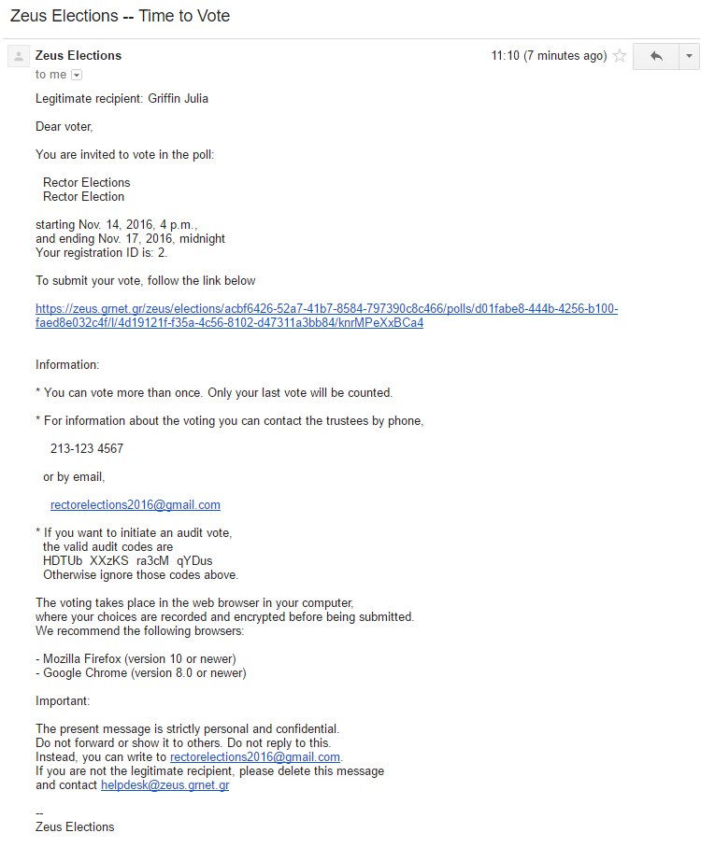
Contact information

Link to Zeus voting web application
Starting/Ending date and time

- E-mail invitation sent to voters
The same message also contains a personal and confidential link to the Zeus voting web application (Figure 1). Using this link, the voter may visit the application at any time and find more info about the election, including the composition of the election committee, the list of candidates, the starting and ending dates. Furthermore, during the time-period specified by the election administrator, the voter will be able to submit his/her vote through the same web application.
It is strongly recommended to save this personal link or the whole message body to a secure offline location, in order to ensure the voter’s being able to access Zeus even if there is no access to his/her e-mail account during the voting period. For example, the user could copy the text into a simple text file and save it to his/her personal computer’s hard-drive or a portable storage device.

Vote Casting
By clicking the link in the e-mail invitation, the voter is redirected to the “digital voting booth” of Zeus. There, the voter has access to information regarding the voting period (Figure 2), the members of the election committee (Figure 3) and the digital ballot (Figure 4).
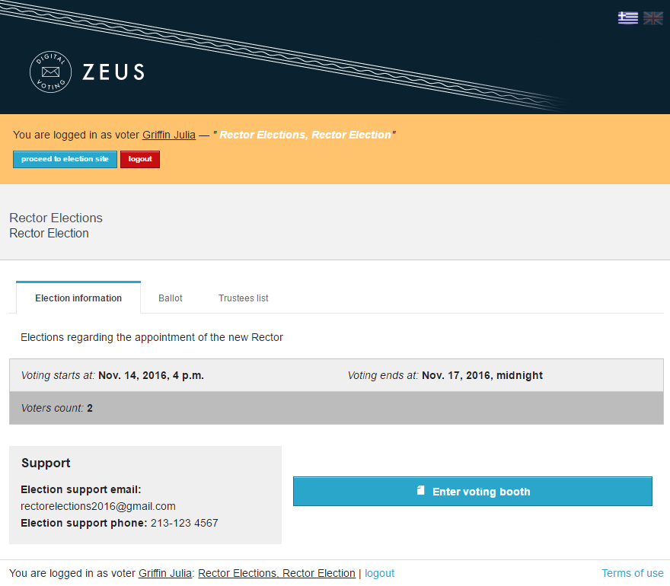

- The “digital voting booth”

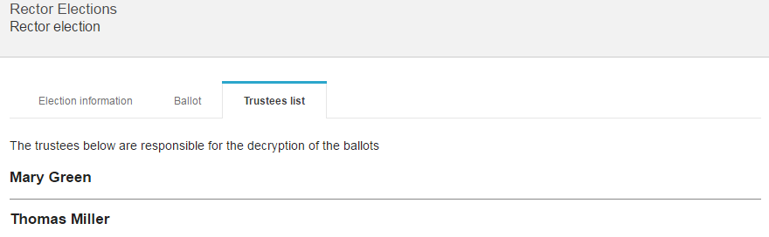
View the election committee
- Composition of the election committee
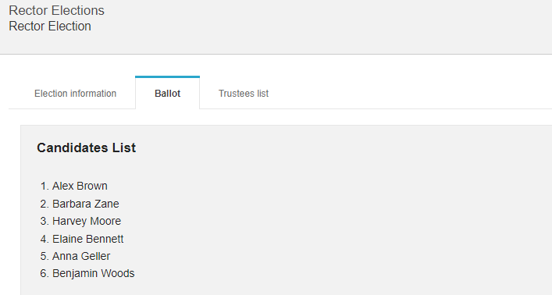
View the Ballot
- Digital ballot

In order to initiate the vote submission process, the voter clicks the “Enter voting booth” button (Figure 2).
At any point, clicking the button labeled “Information” in the top-right corner, brings up a dialog containing a short description of the election’s topic and contact information (Figure 5).
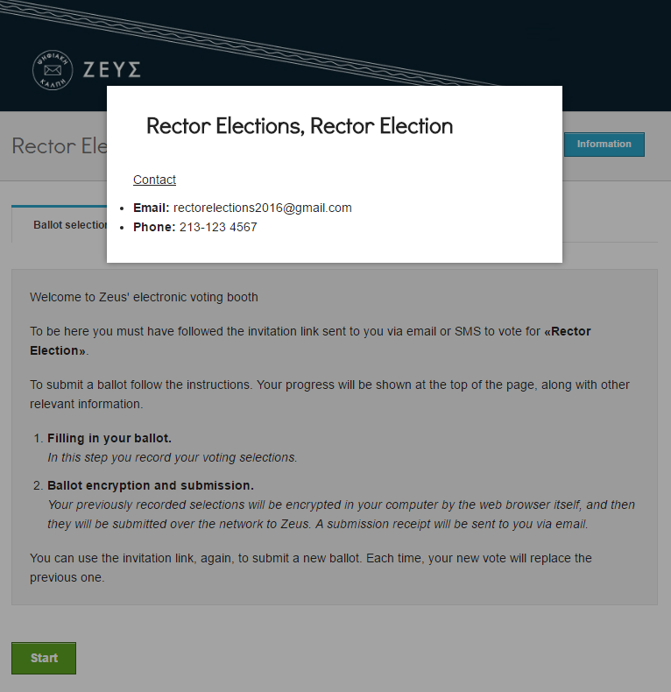
Contact Information

- Short description and contact info

Furthermore, the page contains detailed instructions regarding the ballot submission (Figure 6). The process is completed in two steps:
- Filling in the digital ballot
- Ballot encryption and submission
After reading the instructions the voter can click the “Start” button (Figure 6).
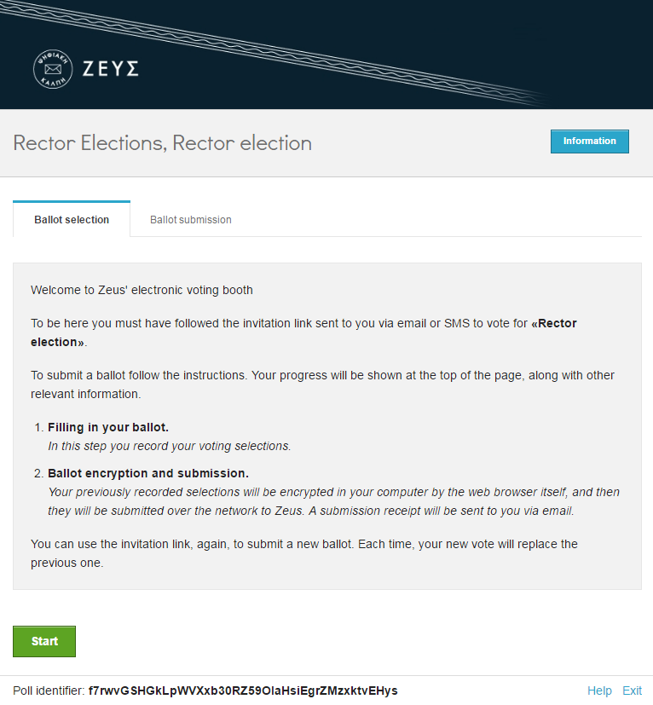
- Initiating the vote submission process
During the first step, the voter interactively fills in the digital ballot according to his/her preferences (Figure 7, Figure 8).
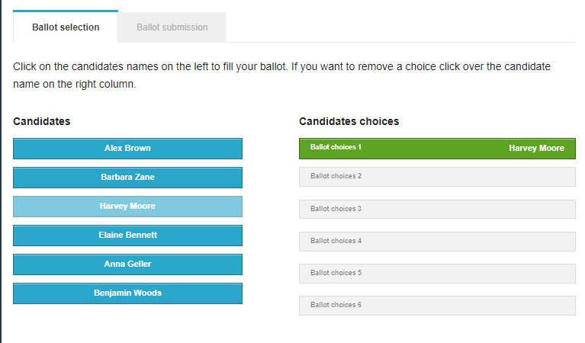
- Filling in the digital ballot (1/2)

In the left column (“Candidates”) the voter may view the candidates’ names. In the right column (“Candidates choices”) the voter’s choices are displayed in order of preference. The voter is requested to indicate his/her preference for candidates, by selecting them with the corresponding series. The voter selects the candidate of his/her first choice, then the second one, and so on. The voter may choose any number of candidates, from none (so the ballot is considered “blank vote”) to all.
In order to select a candidate, the voter has to simply click on his/her name on the left column. The selected candidate appears then on the right column (“Candidates choices”) (Figure 7). In the same way, the voter may select the candidate of his/her second choice, and so on (Figure 8). The blue background color designates an unselected candidate, while the candidates that have already been selected appear on green background. In a similar way, to remove a candidate from his/her choices, the voter simply clicks on the candidate’s name on the right column.

- Filling in the digital ballot (2/2)

As soon as the voter has finished filling in the digital ballot, he/she can proceed to the next step by clicking the “Continue” button at the bottom of the page (Figure 9).
- Proceed to step 2 of the vote submission process

At this stage, the ballot is automatically encrypted by the voter’s web browser in order to ensure vote confidentiality. This operation may last a few seconds, depending on the processing power of the voter’s computer. Before the final submission of the encrypted vote to the server, the user has the chance to review his/her choices (Figure 10). If the user wishes to modify any of his/her choices, he/she can return to the previous step by clicking the “Back to ballot selections” button (Figure 10).
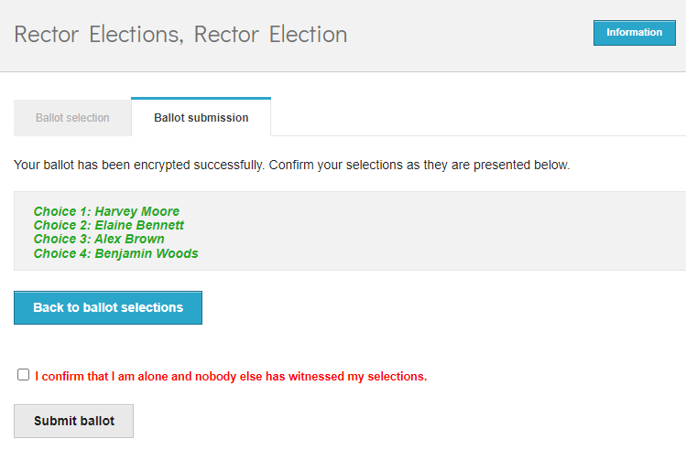
Return to step 1
Confirm choices
- Reviewing one’s choices

Before submitting a vote to the server, the user has to confirm that he/she is alone in front of the terminal and nobody else has witnessed his/her selections”, by checking the appropriate checkbox (Figure 11). Finally, the vote can be submitted by clicking the “Submit ballot” button.
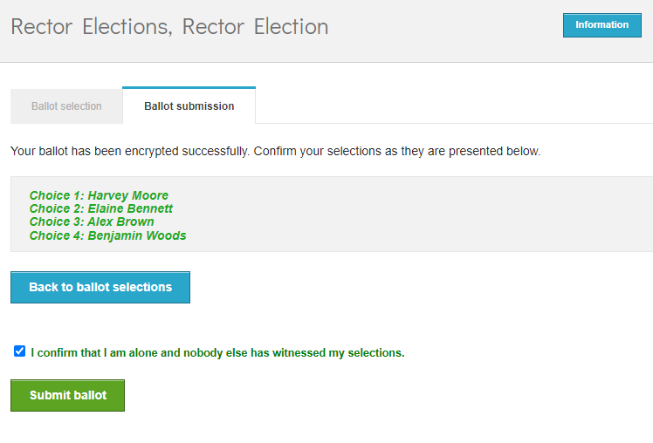
1
2

- Final submission

The encrypted ballot is sent to the Zeus server, which in turn informs the user that the vote has been recorded successfully (Figure 12, Figure 13). At the same time, a digital vote receipt is automatically issued and sent to the voter’s e-mail address in plain-text format (Figure 13).
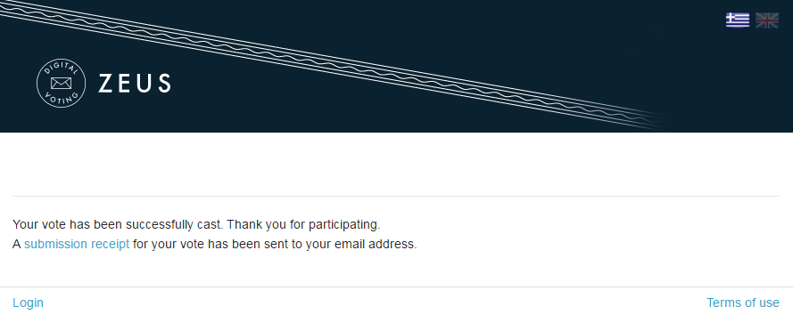
- Successful vote submission

It is the voter’s responsibility to safe-keep this file, as its presentment is necessary for the review of a ballot challenge. It is recommended to save the receipt locally, on the user’s personal computer (or any other secure medium), in order for the file to be accessible even when there is no access to the user’s e-mail account. The file is available either for download from the vote submission confirmation page (Figure 12) or as attachment to the e-mail message sent to the voter (Figure 13).
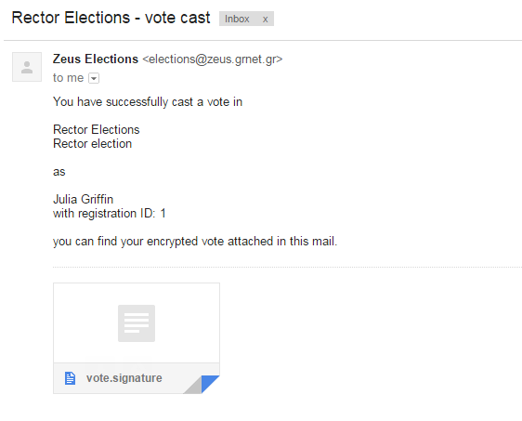
Attached
digital vote receipt
- E-mail message with digital vote receipt

NOTE:
Voters are allowed to submit as many votes as they wish as long as the polls are open. This is a standard feature in electronic voting to guard against coercion. As the voters do not vote in a controlled environment (polling station), it is possible that they vote under duress. If this is so, they can then cast a vote reflecting their true choice later. Every new vote automatically voids the previous one and the proof of the previous vote’s cancellation is included in the new digital vote receipt sent to the user.

Prerequisites
A personal computer with an active internet connection is all that is needed for a voter to participate in the election.
To ensure the voters’ access to Zeus, even if there is no access to their e-mail account during the voting period, it is recommended to save the relevant e-mail message to a secure offline location (personal computer’s hard-drive, portable storage device, etc.).
One of the supported web browsers should be installed on the user’s personal computer. If not already installed, the supported web browsers can be downloaded by following the links below:
- For Google Chrome: https://www.google.com/chrome/
- For Mozilla Firefox: https://www.mozilla.org/firefox/
In order to secure your personal computer and data, it is recommended to follow these guidelines:
- Keep the computer’s operating system up-to-date and make sure to always install the latest security patches.
- Use firewalls and antivirus software.
- Ensure any browser plug-ins/add-ons are kept up-to-date.
- Do not install or use third-party toolbars in your web browser.

