Zeus Voter Manual
- Each voter receives an e-mail invitation (see below), which contains all necessary information for participating in the election. The message also contains a personal and confidential link to the Zeus voting web application.
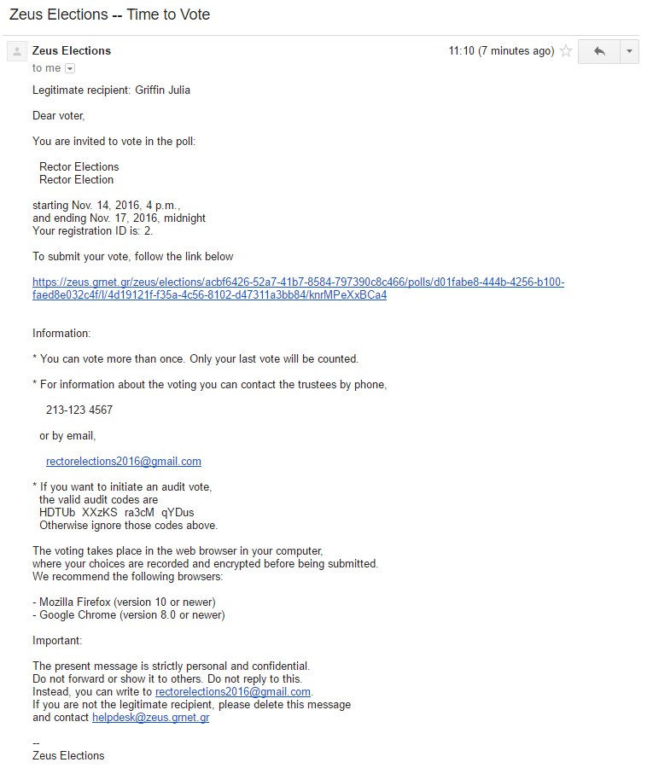
Figure 1. E-mail invitation sent to voters
- Using this link, the voter may visit the “digital voting booth” of Zeus.
- During the specified voting period, electors can submit their votes by clicking the “Enter voting booth” button (Figure 2).
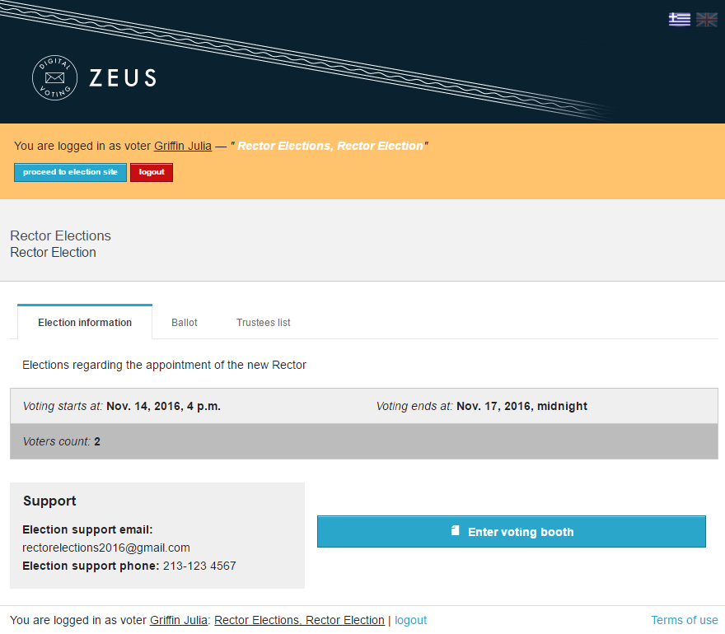
Figure 2. The “digital voting booth”

- After reading the instructions the voter can click the “Start” button.
- The maximum number of choices is displayed above the list of available options.
- In order to select a candidate, the voter clicks on the corresponding name in the list of all candidates (Figure 3). The background color automatically changes from blue to green.
- As soon as the voter has finished filling in the digital ballot, he/she can proceed to the next step by clicking the “Continue” button, at the bottom of the page (Figure 3).
(Note: Submitting a “blank vote” is always possible, by not selecting any candidate.)

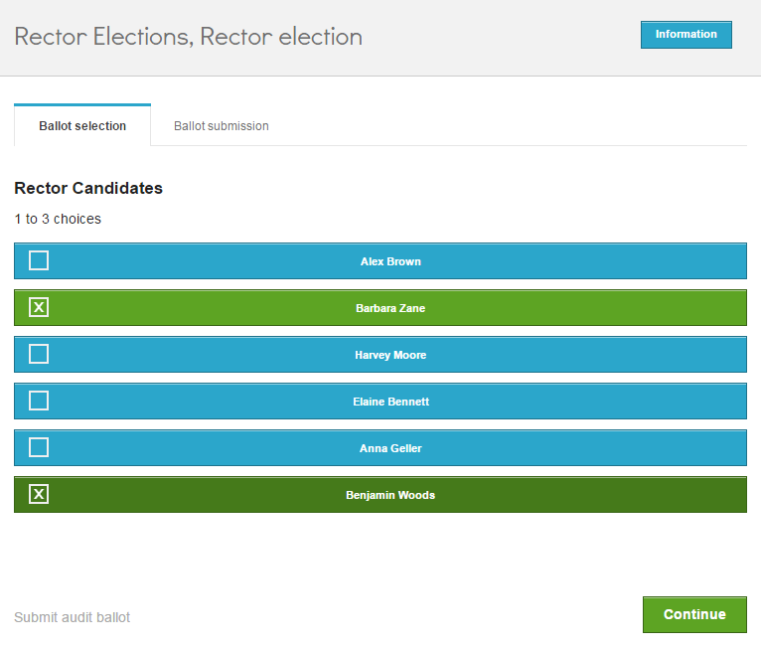
Figure 3. Filling in the digital ballot

- Having reviewed his/her choices, the user may submit the vote by clicking the “Submit ballot” button (Figure 4). For the button to be enabled, the voter has to confirm that he/she is alone in front of the terminal and nobody else has witnessed his/her selections.
- If the user wishes to modify any of the choices, he/she can return to the previous step by clicking the “Back to ballot selections” button (Figure 4).
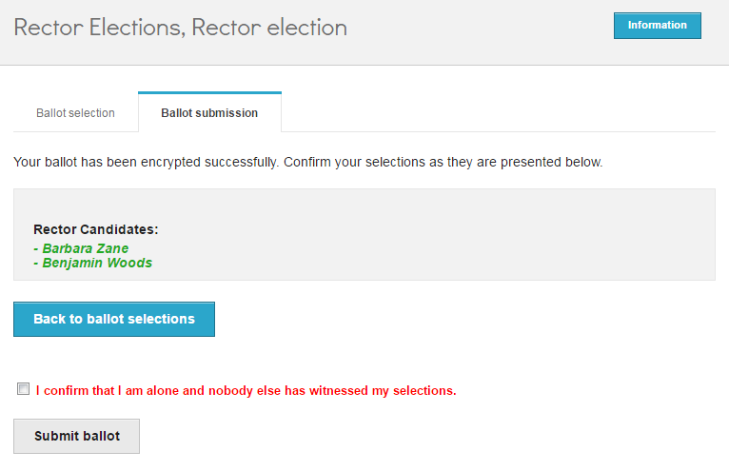
Figure 4. Reviewing one’s choices and submitting

- Upon successful submission, a digital vote receipt is automatically issued and sent to the voter’s e-mail address (Figure 5).
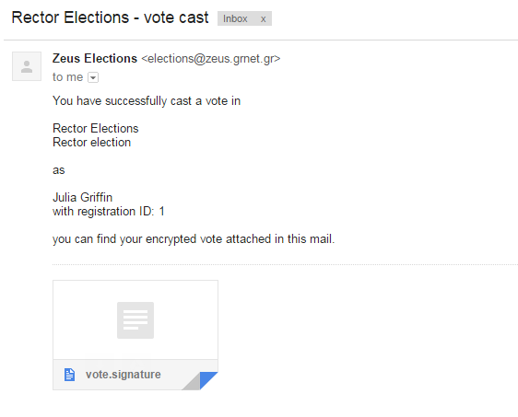
Figure 5. E-mail message with digital vote receipt

NOTES:
- To ensure the voters’ access to Zeus, even if there is no access to their e-mail account, it is recommended to save the relevant e-mail message to a secure offline location (local hard-drive, portable storage device, etc.).
- One of the supported web browsers should be installed on the user’s personal computer. If not already installed, the latest versions of the supported web browsers can be downloaded by following the links below:
For Google Chrome: https://www.google.com/chrome/
For Mozilla Firefox: https://www.mozilla.org/firefox/

- Voters are allowed to submit as many votes as they wish as long as the polls are open. This is a standard feature in electronic voting to guard against coercion. Every new vote automatically voids the previous one and the proof of the previous vote’s cancellation is included in the new digital vote receipt sent to the user.

