ZEUS
Election Administrator
Manual

Introduction
Zeus is a web-based e-voting platform for conducting verifiable elections in which votes remain confidential and anonymous. All election-related operations, from election setup and configuration by the election organizers to vote submission by voters, are performed remotely over a network connection to the internet.
Voters can access Zeus using a web-browser. The exchange of information is protected by mechanisms similar to those applied to online financial transactions. Voters can submit their votes within the specified time-period and receive a digital vote receipt.
The integrity of the election results is mathematically verifiable through cryptographic methods, without breaching vote confidentiality.
In this document we describe in detail all necessary information for an election administrator (hereafter the admin) to set up, configure and support an online election using “Zeus”. Although this manual is primarily addressed to election administrators and the members of the election committee, it might also prove useful for voters, as it provides an in-depth understanding of the overall process.

Overview

- Election Setup and Configuration.
  - Specifying basic election info
  - Setting up a ballot
  - Importing voters
  - Generating Trustee Keys
  - Finalizing the election
  - Sending e-mail invitations to voters
  - Voter list actions

- Voting Period.
  - Monitoring the voting process

- Election End – Results.
  - Poll closing
  - Mixing and decrypting ballots
  - Counting ballots and exporting results

Election Setup and Configuration

Specifying basic election info

The admin logs into the Zeus admin web application using the credentials provided by the Zeus platform administrator. Initially, the admin is asked to fill in some basic information regarding the election to be created:
- Election type. In order to create an approval voting election, the user chooses “Party lists election” (Figure 1).
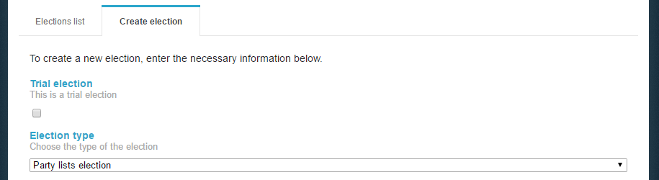
Figure 1. Election type

Note that the admin may choose to create a trial election in order to get familiar with “Zeus” by selecting the corresponding checkbox (Figure 1).

- The election’s name and a short description of the election’s topic (Figure 2).
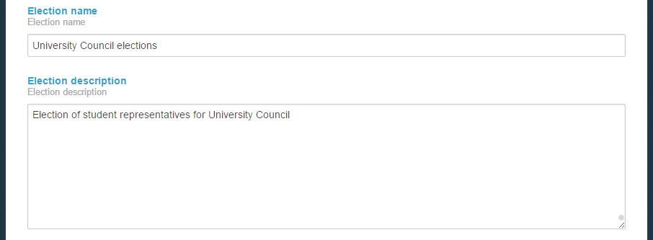
Figure 2. Election name & description

- The starting and ending date and time of the voting period. The Zeus voting web application will allow votes to be submitted only during the time-period specified by these fields (Figure 3).
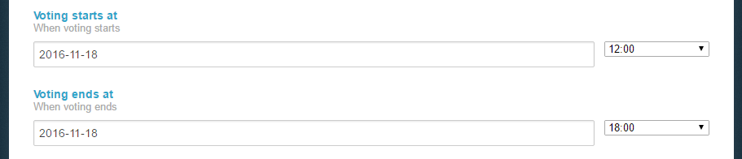
Figure 3. Voting starting & ending date

- Information about the members of the election committee (trustees). The required data are the member’s full name and e-mail address, as shown in (Figure 4). Upon this form (see below), every member of the election committee will receive an e-mail message with instructions on generating their Trustee Key.
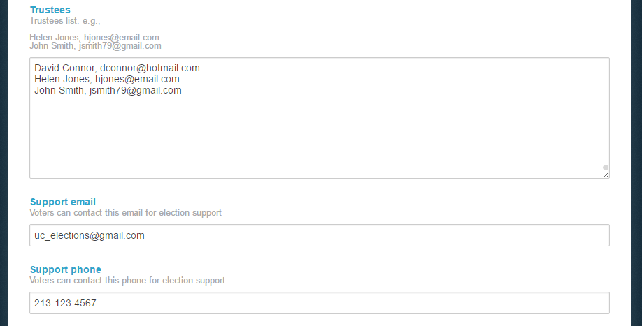
Figure 4. Trustees & voters’ support data

- An e-mail address and a telephone number, where the voters may contact for clarifications and support (Figure 4).

- The communication language that will be used for the voters’ e-mails (Figure 5).

- Optional activation of multiple mixnets. By enabling this option, the host organization will be required to implement external ballot mixing stages that will take place after the polls have closed. The election organizers are exclusively responsible for providing, administering and configuring the hardware and software infrastructure these extra mixing stages will run on. (Figure 5).

- Optional cast consent text to be accepted. By filling in the text in this field, it will appear to the voters and they should accept it in order to complete the cast of their votes (Figure 5)
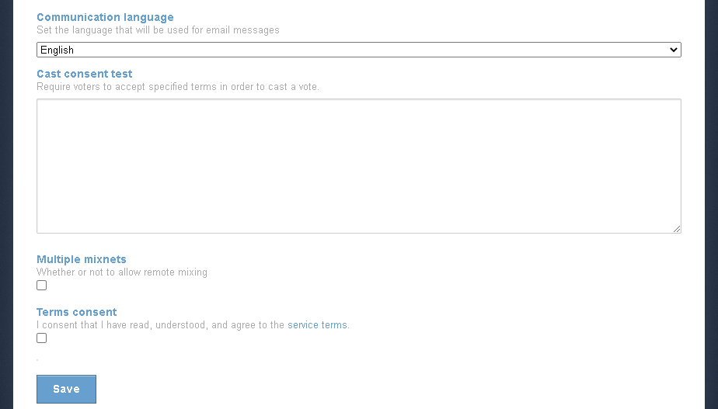
Figure 5. Saving election info

Finally, after filling in the fields described above, the user can click the “Save” button, in order to create the election and move on to the next steps of the election setup process (Figure 5). At any time before the election finalization (see below), the admin is able to return here and modify this info by clicking the “Edit election” tab.

Setting up a ballot

After the election is saved, the user will be transferred in “Polls” tab where he/she should add a poll (Figure 6). Optionally the admin may select to add a 2nd step/factor for voter authentication.
If shibboleth is used as 2nd factor authentication, the admin must declare the email associated with the user's academic login. If everything above is done, when the voter selects the link for voting, he / she will be redirected to the Institution selection page where he / she will then enter his / her academic login details. If voter_email = shibboleth_email then he will see the voting page and will be able to vote. As voter_email = the email entered by the admin in the voter list and shibboleth_email = the email associated with the academic login.
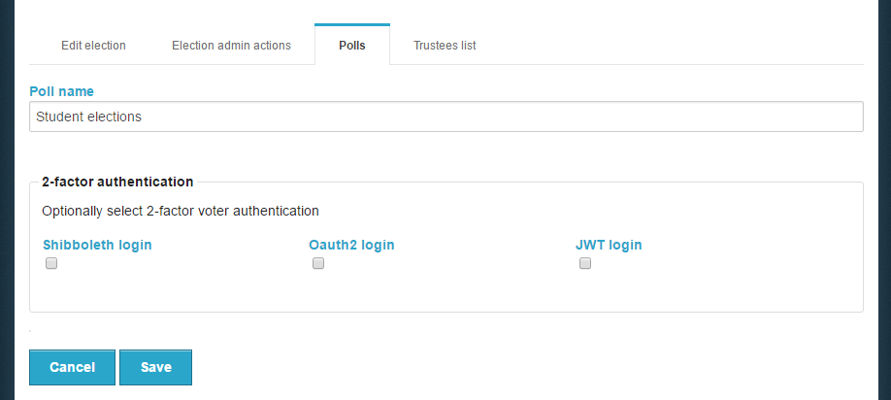
Figure 6. Adding a new poll

Note that the user can add more polls by clicking on “Add poll” (Figure 7).
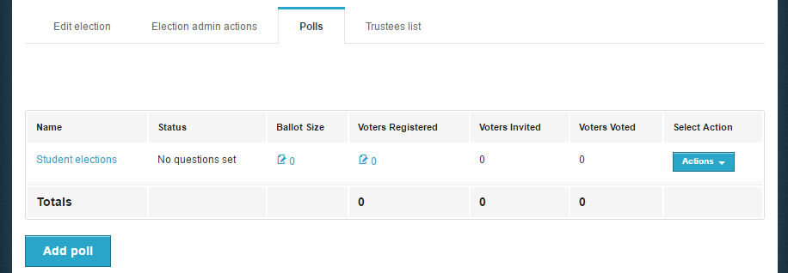
Figure 7. Managing Polls

Subsequently, the admin should set up the digital ballot, by clicking on either the icon on the “Ballot Size” column or the “Actions” button and then the “Manage questions” option (Figure 7). The admin should then enter the parties’ name, the maximum and minimum number of answers (“crosses”) for each party as well as the possible choices (Candidates). The admin may add more than one party per ballot by clicking on the green “+” icon on the left of “Party 1” tab (Figure 8).

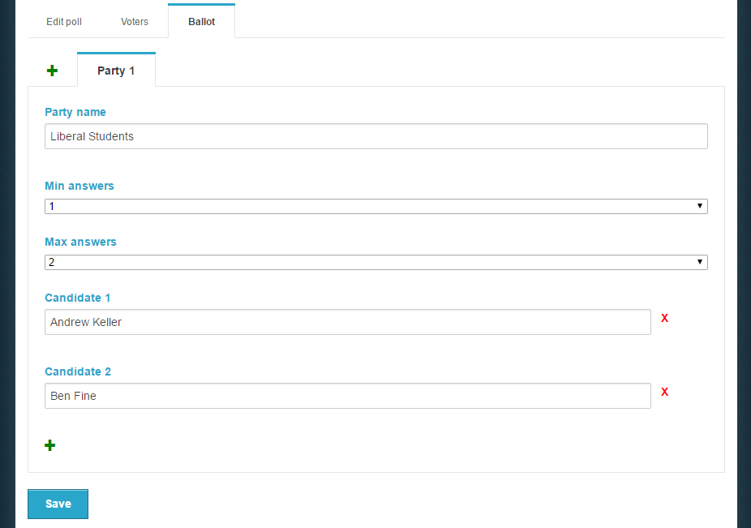
Figure 8. Create ballot

To add more options (candidates), the user clicks on the green “+” in the bottom of the page. In order to remove an option (candidate), the admin clicks on the red “X” next to the corresponding answer (Figure 8Figure 8. Create ballot).
While creating the second poll, the administrator can link it with the first one by selecting «Link voters list to another poll» (Figure 9). This functionality offers the following advantages:
- The voters’ list set for the first poll is connected to the second. The user can make any changes to the voters’ list in the first poll and, since the polls are linked to each other, the changes are applied to the second as well.
- Voters will receive only one URL regarding the vote submission.
- Zeus URL will redirect voters to the system, where they can submit their votes to both ballot boxes.
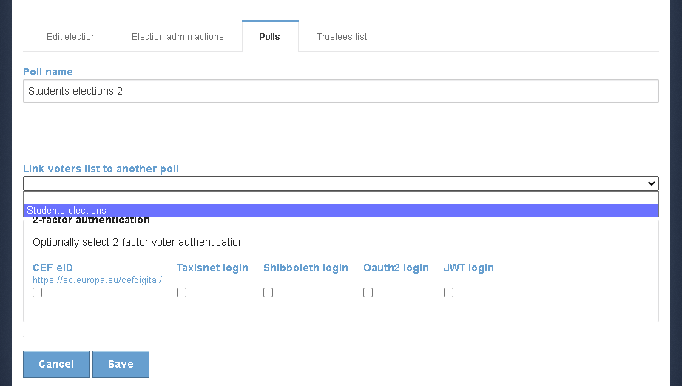
Figure 9. Edit Poll

Linked ballot boxes appear in the following form (Figure 10):

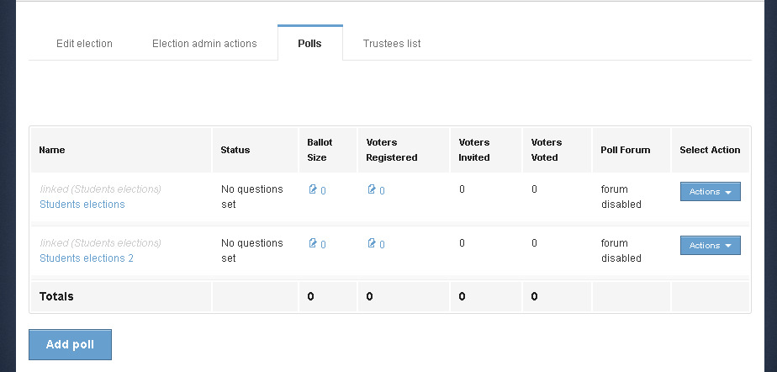
Figure 10. Connected polls
After completing the ballot creation, the user can save the changes by clicking the “Save” button and proceed to the next step.

Importing voters

In this step, the admin will have to import the voters. The user should move to the “Voters” tab, click on the “Voter list actions” button and then select the “Import voters” choice (Figure 11).
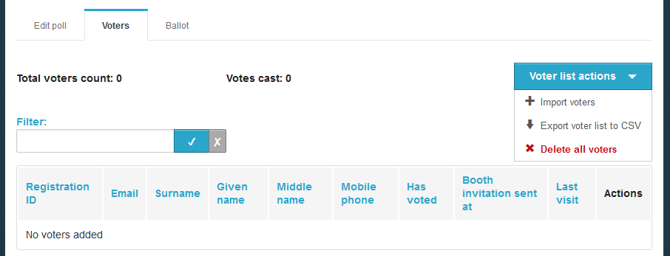
Figure 11. Import voters

Voters are mass imported into the system (Figure 12) by uploading a CSV file (comma-separated values file) in the appropriate format. The required fields for each voter are the registration number, a personal e-mail address, first name and last name. Optionally, the middle name and a personal mobile phone number may be specified as well.
This file, which is basically a specially formatted plain-text file, should contain all voter-specific data as follows:
- Each line should contain all necessary data regarding one single voter.
- The values on each line correspond to the following fields (in this order):
  - Registration number, e-mail, first name, last name, middle name, phone number
- Values on a single line are separated by a comma (“,”).

In order to create the CSV file, the admin can use Microsoft Excel or any similar spreadsheet software. (Figure 12). 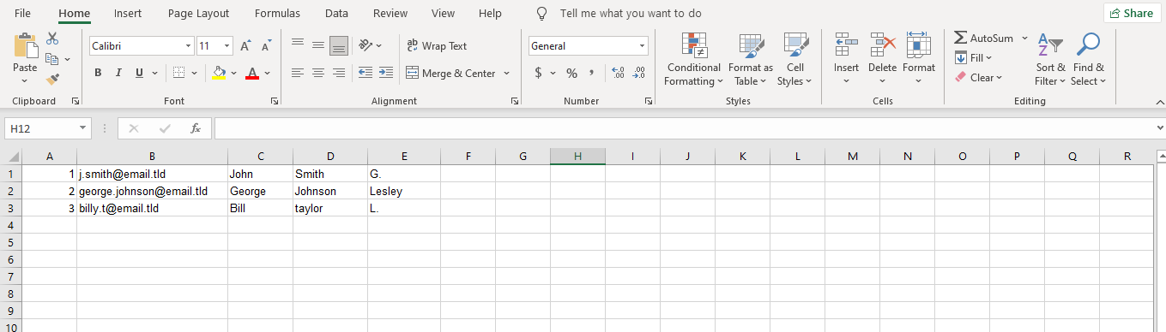
Figure 12. Spreadsheet

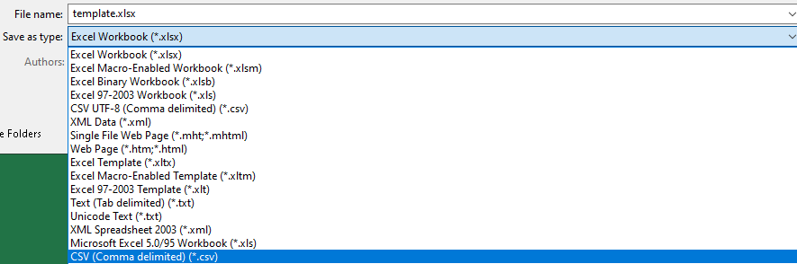
Figure 13. File Format

Then, by selecting "Save As", the various file formats that Excel supports for saving are displayed. From the list, "CSV (Comma delimited)" should be selected. (Figure 13).

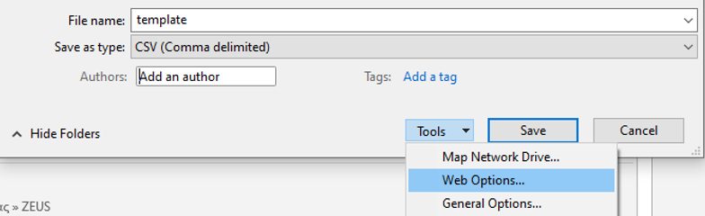
Figure 14. Web Options

Finally, in order to encode the file data, the user may click the “Tools” button and select “Web Options” (Figure 14). From the Encoding tab (Figure 15), in the dropdown menu for “Save this document as” choose Unicode.

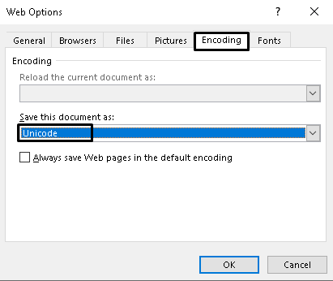
Figure 15. Unicode encoding

Subsequently, the user clicks the “Upload file” button (Figure 16).

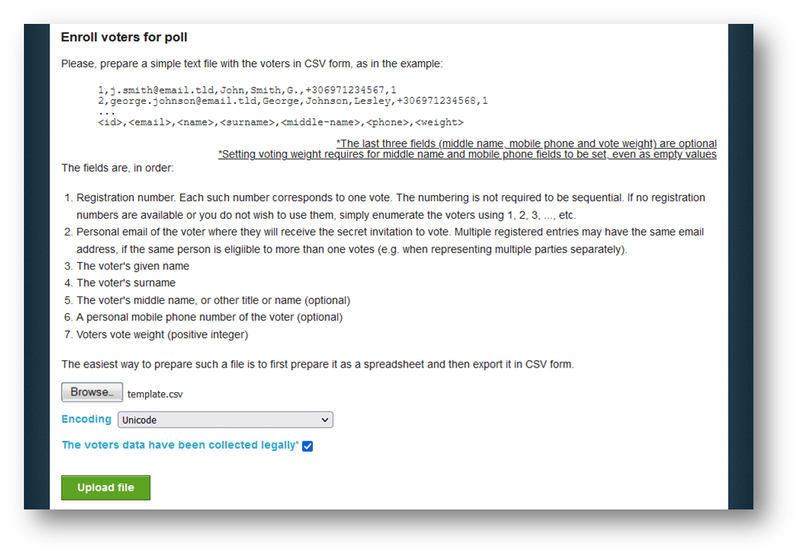
Figure 16. Mass voters’ import

The user selects the CSV file, which must be already created and saved on the user’s device and sets the proper encoding. Subsequently, the user clicks on the “Upload file” button, after he/she has checked that the voters’ data have been collected legally (Figure 16).
Note: Depending on the encoding of the CSV file, either Unicode, Greek (iso-8859-7) or Latin (iso-8859-1) may be selected in Zeus in the “Encoding” field. If the file in Unicode fails, try the other 2 encodings.

The user is redirected then to the “Voters” tab (Figure 17). From this tab, the admin can view the detailed voters’ data and perform mass actions (such as sending e-mail to voters, re-importing voters, exporting voters list and deleting all voters). The user may also perform actions on specific/individual voters (send e-mail, search for voter, delete voter).
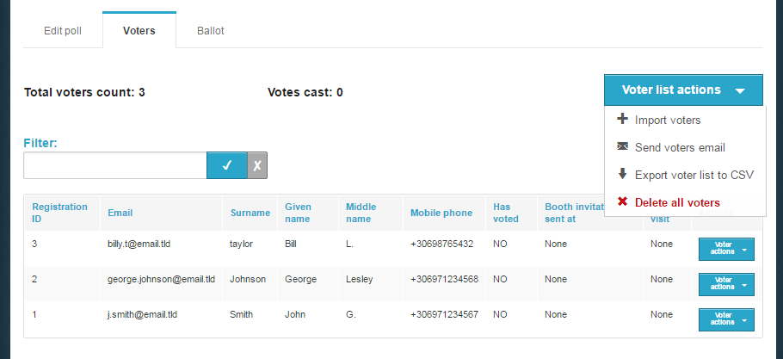
Figure 17. List of voters and related operations

Generating Trustee Keys

The last step before finalizing the election is the generation of the Trustee Keys by the members of the election committee. These keys will be used for the encryption of ballots and the decryption of their anonymized content in order to determine the final result.
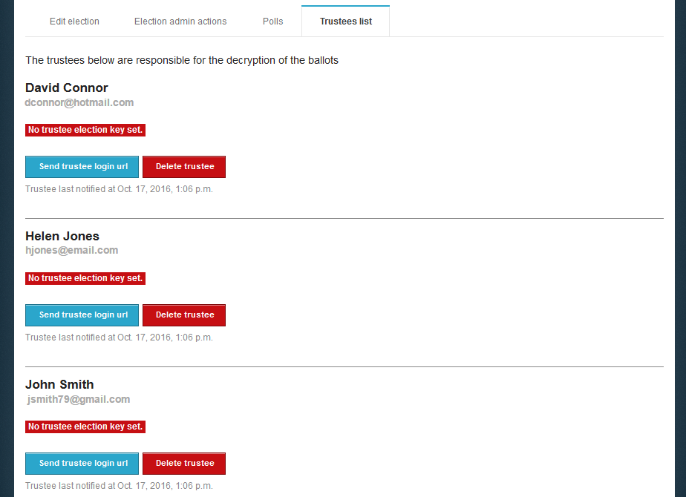
Figure 18. The “Trustees list” tab

Through the “Trustees list” tab the admin can monitor the progress of the key generation process for each trustee (Figure 18). From there, the user may resend to a trustee the e-mail message with the login URL or even remove a member from the election committee in case of an error.
When an election is created, every member of the election committee automatically receives an e-mail message with instructions on how to generate their Trustee Key (Figure 19). This message contains a personal, unique link for each trustee (Figure 19). The trustee should click on this link in order to create his/her Trustee Key.
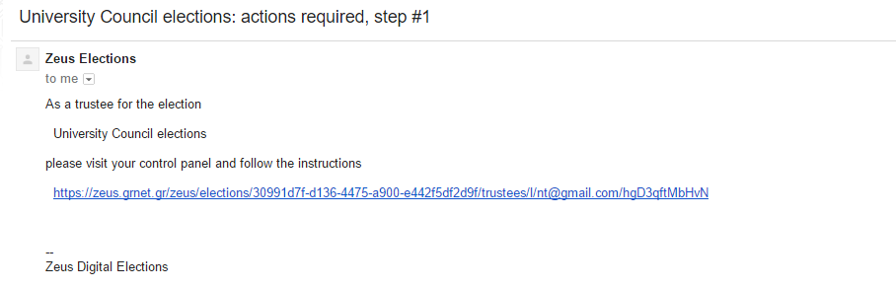
Figure 19. E-mail sent to Trustee

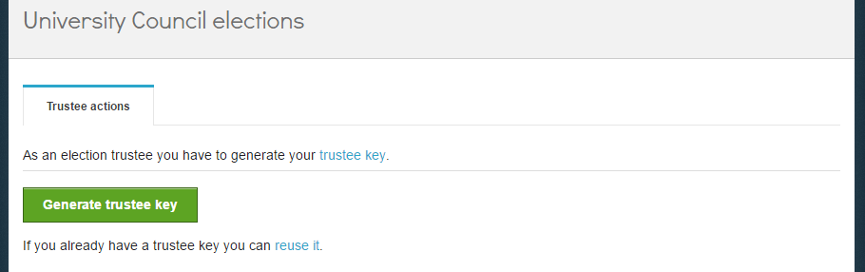
Figure 20. Trustee Key generation

By clicking the button “Generate trustee key” (Figure 20), a Trustee Key is generated in the user’s web browser automatically (without any involvement of the Zeus server). The user is asked to save the Trustee Key locally (e.g. on his/her personal computer’s hard-drive, on a portable storage device, etc.) by clicking the “Save your trustee key” button (Figure 21). This file must be kept safe and confidential until the election’s closing, since it is required for the decryption of the anonymized ballots and the review of any ballot challenges.
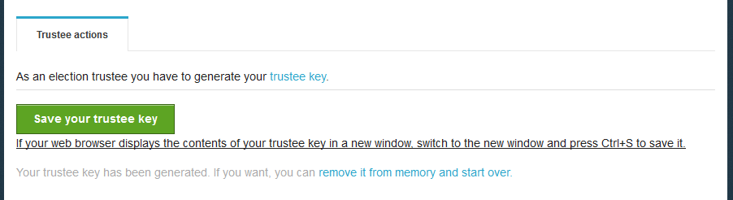
Figure 21. Trustee Key storage

After ensuring the Trustee Key is safely stored, the user may proceed to activate it by clicking the “Activate trustee key” button (Figure 22). At this point, the public part of the Trustee Key is sent to Zeus in order to be used in the encryption of ballots. The private part of the Trustee Key, which is contained only in the local file saved by the user, will be required later on, at the ballot decryption stage.
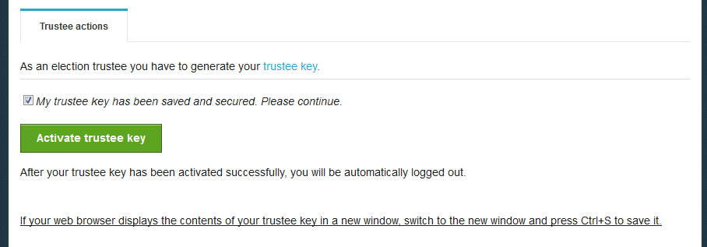
Figure 22. Trustee Key activation

The final step, which is also a prerequisite for the finalization of the election, is the verification of the generated Trustee Keys. The purpose of this step is to ensure that all members of the election committee have successfully saved their Trustee Keys and will be able to recover them when needed.
A new e-mail message with further instructions is sent to each member, prompting them to visit Zeus once more and verify their generated Trustee Key. The user must follow the link included in the message and click on “Confirm key possession” (Figure 23).
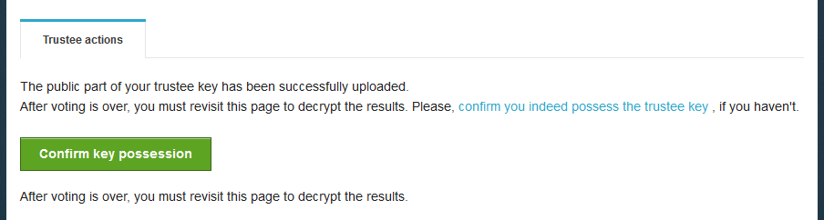
Figure 23. Trustee Key verification (1/2)

The user is asked to browse his/her file-system and select the file containing his/her Trustee Key. Then, the user clicks the “Verify” button in order to trigger the verification process (Figure 24). Once the application successfully verifies the Trustee Key, the user is automatically logged out.
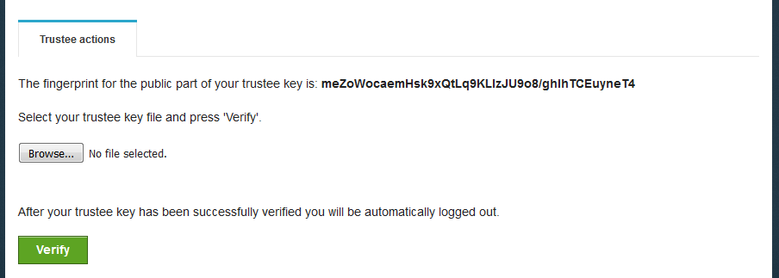
Figure 24. Trustee Key verification (2/2)

Finalizing the election

After the completion of the steps mentioned above, the admin may move on to the finalization of the election by clicking the “Freeze election” button in the “Election admin actions” tab (Figure 25). Once an election is finalized, its basic data is not allowed to be modified (e.g. the starting date, the members of the election committee, the list of candidates, etc.). However, some data such as the ending date (which may be postponed) or the voters’ list remain modifiable.
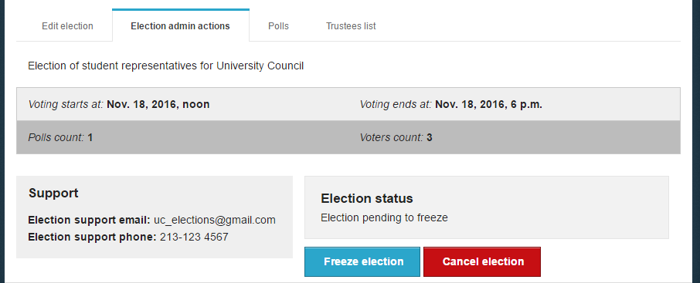
Figure 25. Election finalization

Sending e-mail invitations to voters

Following the finalization of the election, the admin should visit the “Polls” tab, where he can configure and send mass e-mail invitations to the voters. Each invitation contains a personal and confidential link to the Zeus voting web application. Using this link, the voter will be able to visit the election page at any time and find more info about the election, including the composition of the election committee, the list of candidates, the starting and ending dates, contact details for election support, etc. Furthermore, the voter will be able to cast his/her vote during the time-period specified by the admin.
The admin clicks on the “Batch polls actions” button and then on “Send voters email” (Figure 26).
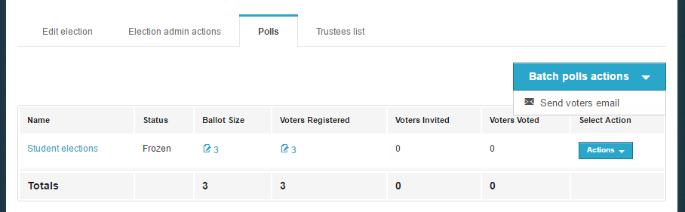
Figure 26. Batch polls actions

The admin may view a template of the e-mail that will be sent to the voters (Figure 27). The user may specify the subject of the automatically generated e-mail message and/or add extra information to the message’s body, such as further details, instructions, etc. (Figure 28). Finally, by clicking the “Send” button, the application starts to gradually send out the invitations. The duration of this procedure varies based on the number of voters. (Usually, it completes within a period of a few minutes to a couple of hours.)

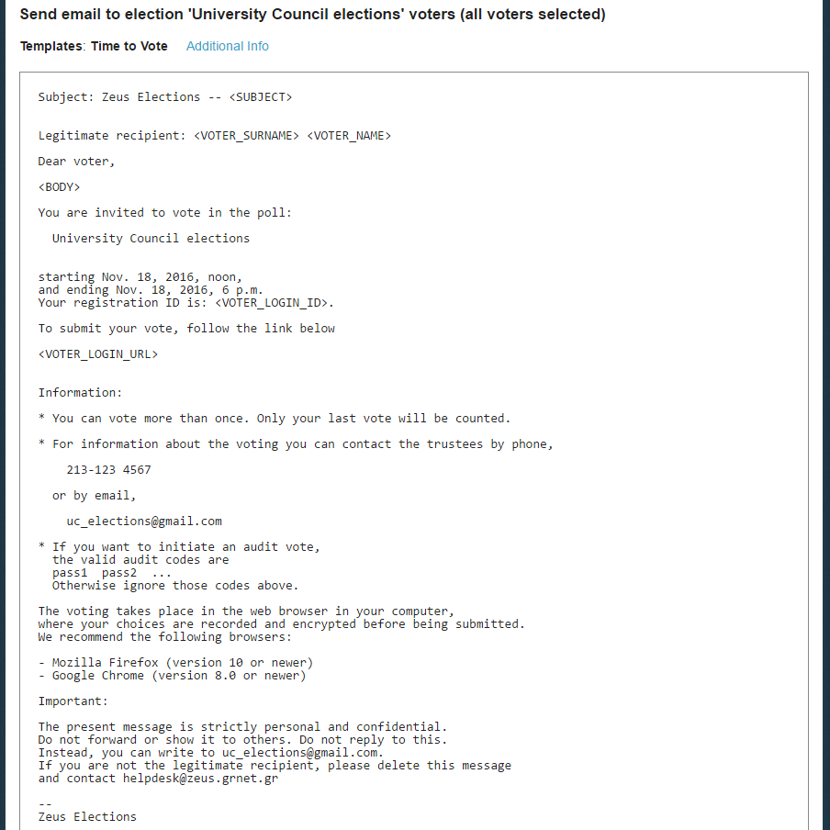
Figure 27. Template voter e-mail
Figure 28. Editing/Sending e-mail

Voter list actions

During the voting procedure, incorrect registrations may be observed in the voter list (invalid email, incorrect voter details, etc.). The admin can delete a voter from the list. The voter list can be displayed either by selecting the Voters icon (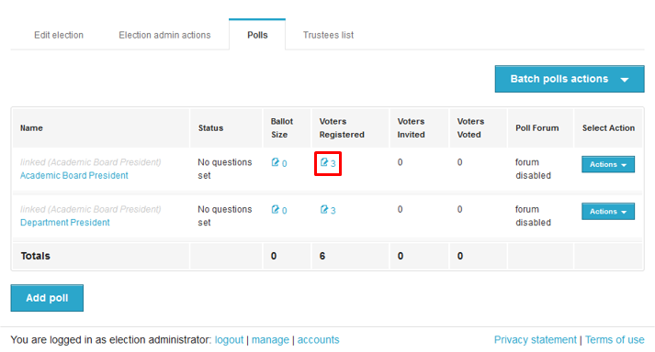Figure 29) or by clicking the "Actions" button and then selecting "Manage Voters" (Figure 30).

Figure 29. Manage voters

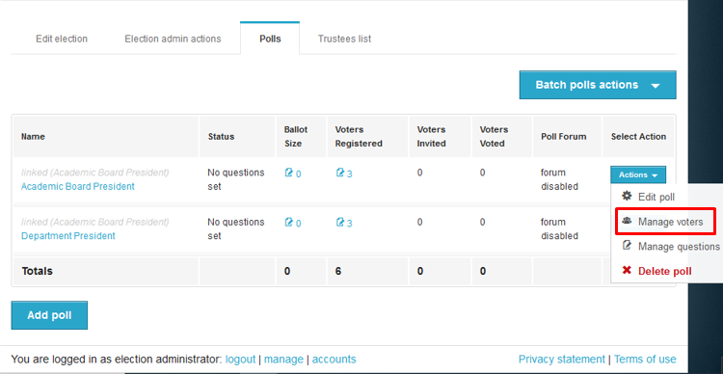
Figure 30. Manage voters

Then, the admin can remove the voter, by clicking on "Voter Actions" and selecting "Delete Voter" (Figure 31).

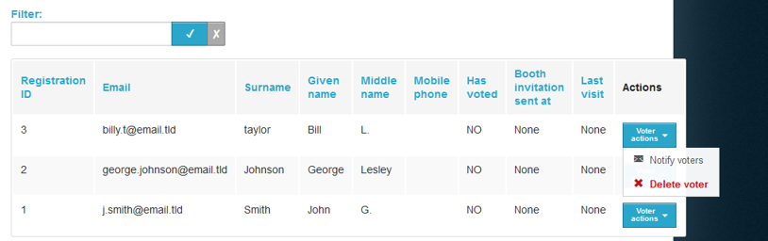
Figure 31. Delete voter

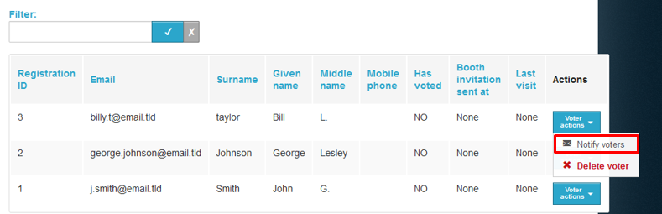
If the deletion of a voter has to do with incorrect data, the admin can make the necessary corrections and import the voters that had been removed, as described in the step "Importing voters" above. Finally, if the admin has already sent the e-mail invitations to voters, a new mail must be sent to the voters added afterwards, in order to participate in the election. Therefore, the administrator should click the "Voter Actions" button and select "Notify Voters" (Figure 32). The above procedure must be repeated for the total number of new registered voters.

Figure 32. Notify voters

Voting Period

Monitoring the voting process

During the voting period, the admin has access to real time data enabling him/her to monitor the progress of the voting process.
The following information can be found in the “Polls” tab (Figure 33):
- Total number of voters
- Total number of votes cast
- Detailed record of the electors that have voted
- Sent date of the last e-mail invitation per voter
- Date of the last visit to the voting application per voter
Additionally, the admin is able to perform various actions (Figure 33), such as:
- Resend e-mail invitation to a voter
- Remove a voter
- Add/Edit a voter (by importing a new CSV file)
- Send custom e-mails to a specific group or all voters
- Export voter list in CSV format
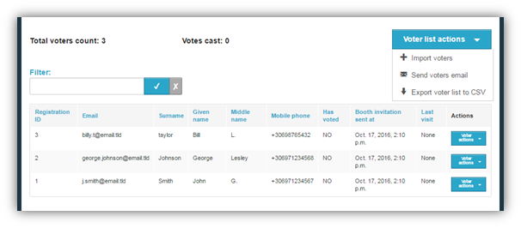
Figure 33. Monitoring the voting process

Election End – Results

Poll closing

At the specified ending date and time, vote submission is automatically disabled. However, the admin may postpone the ending date (even at this point) if the election organizers decide there are justifiable reasons. After visiting the “Edit election” tab, the admin can extend the voting period, by specifying a later date in the “Voting extended until” field (Figure 34) and clicking the “Save” button.
Figure 34. Extending the voting period

In order to conclusively end the voting process, the admin has to visit the “Election admin actions tab” and click the “Close election” button (Figure 35). After confirming the action by clicking the “End” button in the confirmation dialog that appears (Figure 36) the voting process is completed. After closing the election, no modification of its data is allowed.

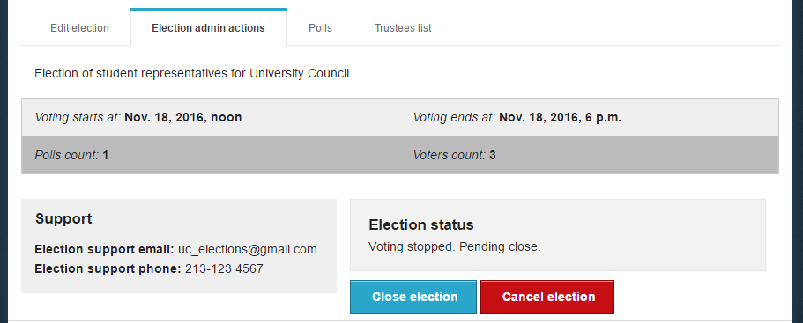
Figure 35. Closing election

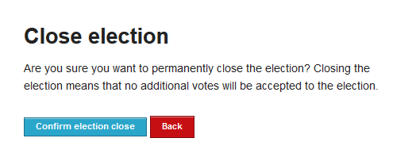
Figure 36. Confirming election closing

Mixing and decrypting ballots

Once the election has been closed by the admin, the mixing of ballots starts automatically. This mixing stage (along with any external mixing stages performed by the election organizers) in conjunction with the previous encryption of ballots anonymizes the ballots, ensuring vote confidentiality. From the “Election status” the admin can monitor the mixing progress (Figure 37).
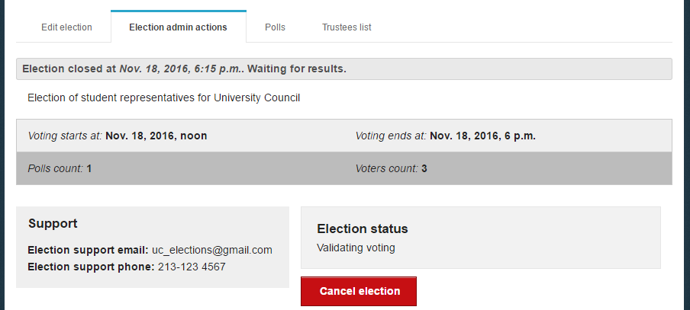
Figure 37. Starting ballot mixing

As soon as the mixing stage has been completed and before being able to determine the outcome of the election it is necessary to decrypt the anonymized ballots using all Trustee Keys (Figure 38). A new e-mail message is sent to each member of the election committee, instructing them to visit Zeus and complete the partial decryption of the election data using their Trustee Key.
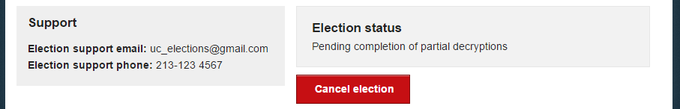
Figure 38. Finishing ballot mixing

Every member of the election committee has to visit Zeus (by following their personal link) and browse their file-system in order to select the file containing their Trustee Key (Figure 39). Then, they should click the “Perform partial decryption” button, in order to start the partial decryption process (Figure 40).
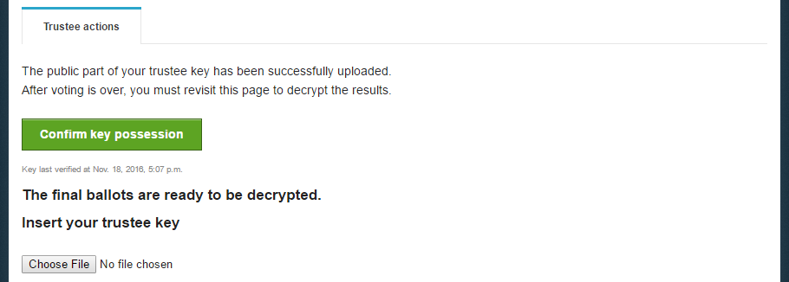
Figure 39. Inserting Trustee Key

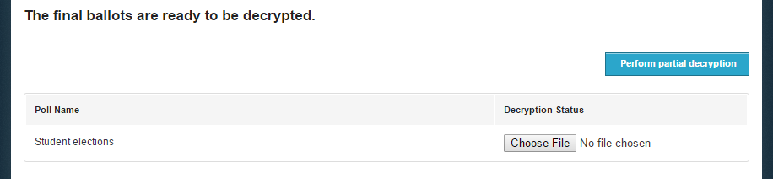
Figure 40. Performing ballot partial decryption

The duration of the partial decryption process varies based on the type of the election and the total number of votes. When the process finishes the message “Decryption uploaded.” appears in the decryption status.

Counting ballots and exporting results

Having collected the output from all partial decryptions, “Zeus” will automatically process the data, determine the election results and display them to the admin. The admin can monitor the election status until its completion from the “Election admin actions” tab (Figure 41). From the same tab the admin has the option to download the results report for offline access in PDF or ZIP format, whereas from the “Polls” tab he/she may view and export the results of each poll separately (Figure 42).
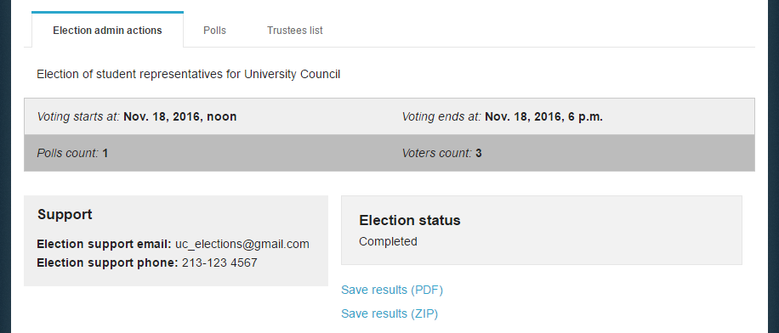
Figure 41. Viewing and exporting election results

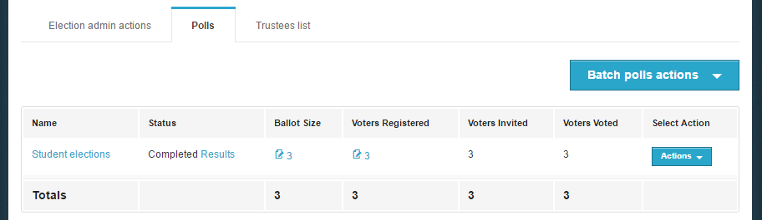
Figure 42. Viewing and exporting poll results

Prerequisites

A personal computer with an active internet connection is the only prerequisite for a user (administrator, member of the election committee, elector) to access Zeus. One of the supported web browsers should be installed on the user’s personal computer. If not already installed, the supported web browsers can be downloaded by following the links below:
- For Google Chrome: https://www.google.com/chrome/
- For Mozilla Firefox: https://www.mozilla.org/firefox/

In order to secure your personal computer and data, it is recommended to follow these guidelines:
- Keep the computer’s operating system up-to-date and make sure to always install the latest security patches.
- Use firewalls and antivirus software.
- Ensure any browser plug-ins/add-ons are kept up-to-date.
- Do not install or use third-party toolbars in your web browser.

If necessary, the election organizers may decide to prolong the voting period at a later time.
Losing any of the Trustee Keys after finalizing the election makes it impossible to decrypt the ballots and determine the result of the election. Each member of the election committee is responsible for safe-keeping his/her Trustee Key.
Members of the election committee cannot be removed after the finalization of the election.
Note that visiting the voting application does not necessarily imply vote casting.
Removing a voter is possible only as long as he/she has not cast a vote.

